# **DESCRIPTIVE AND INFERENTIAL STATISTICS**

**Descriptive and inferential statistics are two fields of statistics.**

1. Descriptive statistics is used to describe data.
2. Inferential statistics is used to make predictions.

**What is Descriptive and Inferential Statistics?**

1. Descriptive statistics helps to describe and organize known data using charts, bar graphs, etc.
2. Inferential statistics aims at making inferences and generalizations about the population data.

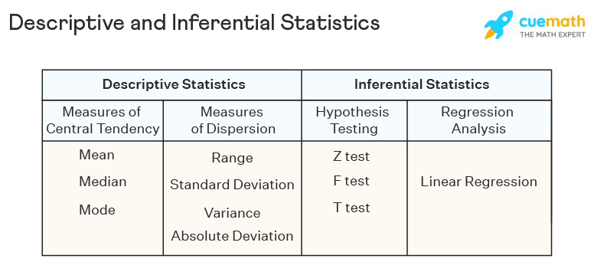

## **DESCRIPTIVE STATISTICS**

Descriptive statistics are a part of statistics that can be used to describe data. It is used to summarize the attributes of a sample in such a way that a pattern can be drawn from the group. Descriptive statistics uses two tools to organize and describe data. These are given as follows:

* **Measures of Central Tendency** - [**mean**](https://www.cuemath.com/data/mean/)**,**[**median**](https://www.cuemath.com/data/median/)**,** [**mode**](https://www.cuemath.com/data/mode/).
* **Measures of Dispersion** - These measures help to see how spread out the data is in a distribution with respect to a central point. [**Range**](https://www.cuemath.com/data/range-in-statistics/)**, standard deviation,**[**variance**](https://www.cuemath.com/data/variance/)**, quartiles,** [**absolute deviation**](https://www.cuemath.com/mean-deviation-formula/)are the measures of dispersion.

## **INFERENTIAL STATISTICS**

1. Inferential statistics is a branch of statistics that is used to **make inferences about the population by analyzing a sample**.
2. Certain samples are taken that are representative of the entire population.
3. Inferential statistics draws conclusions regarding the population using these samples. Sampling strategies such as simple random sampling, cluster sampling, stratified sampling, and systematic sampling, need to be used to choose correct samples from the population.
4. Some methodologies used in inferential statistics are as follows:

* [Hypothesis Testing](https://www.cuemath.com/data/hypothesis-testing/) - [**z test**](https://www.cuemath.com/data/z-test/)**,**[**f test**](https://www.cuemath.com/data/f-test/)**, t test, Chi-Square, ANOVA** .
* Regression Analysis - Such a technique is used to check the relationship between dependent and independent variables. The most used type of regression is linear regression.

**Difference Between Descriptive and Inferential Statistics**

| **Basis** | **Descriptive Statistics** | **Inferential Statistics** |
| --- | --- | --- |
| Definition | Descriptive statistics is used to describe the characteristics of the population using a sample. | Inferential statistics uses various analytical tools to draw inferences about the population using samples. |
| Tools | [Measures of central tendency](https://www.cuemath.com/data/measures-of-central-tendency/) and measures of dispersion. | Hypothesis testing and regression analysis. |
| Use | Organizes, describes and presents data in a meaningful way with the help of charts and graphs. | Tests, predicts, and compares data obtained from various samples. |
| Relevance | It is used to summarize known data in a way that can be used for further predictions and analysis. | It tries to use the summarized samples to draw conclusions about the population. |